Market Monitor - Bangladesh - 2026-05

Highlights
The cost of the food basket saw a marginal increase in May, driven by a sharp rise in egg prices that was largely offset by falling prices for staple foods like rice. Overall, the basket remains significantly more affordable than a year ago.
The national cost of the "MEB" was 1,500.8 BDT, reflecting a slight month-on-month increase of 0.6% but a year-on-year decrease of 9.2%.
Prices of key commodities showed mixed trends. The price of eggs (brown) surged month-on-month (↑16.1%), while imported onions saw a sharp decrease (↓23.6%). Annually, the price of chili continued to show a strong upward trend (↑31.0%).
Key drivers for this month's price changes include:
- A sharp month-on-month price increase for eggs (↑16.1%) was the primary upward pressure on the food basket cost.
- This increase was largely counteracted by a price decrease for coarse rice (↓1.8%), the most heavily weighted item in the food basket.
- Significant price drops for other commodities, including imported onions (↓23.6%) and chickpeas (↓17.0%), also helped to moderate the overall cost.

Basket Definitions
Basket / role | Description | Scope | Composition
MEB (Primary) | Primary MEB reference basket configured by the Country Office. | National | 0.2 KG Chickpeas; 0.2 KG Chili (whole, dry, Indian Teja); 15 1 piece Eggs (brown); 0.3 KG Fish (dry, belt 10-12"); 1 KG Lentils (masur); 0.5 KG Meat (chicken, broiler); 1.1 L Oil (soybean, fortified); 0.2 KG Onions (imported, China); 0.8 KG Potatoes (Holland, white); 12.3 KG Rice (coarse); 0.1 KG Salt (iodized, Molla); 0.1 KG Sugar; 0.8 KG Wheat flour

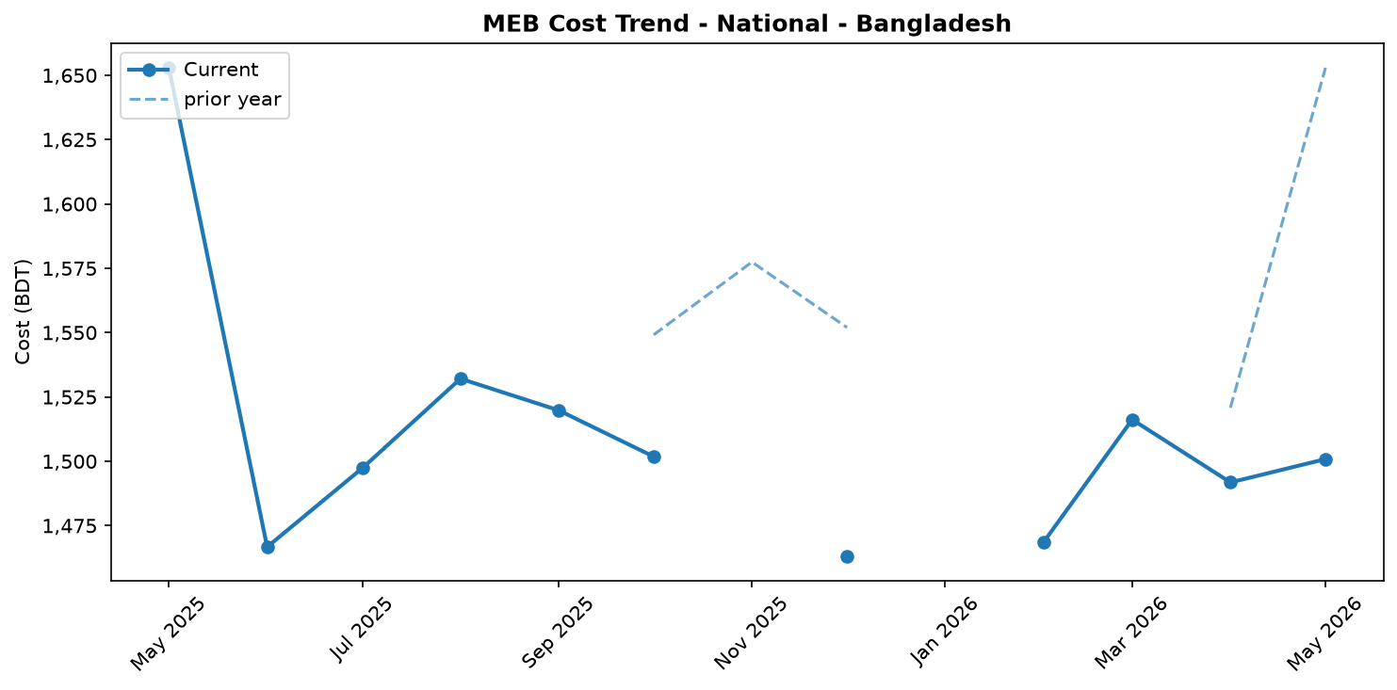
MEB cost trend (National)

Market Overview
Market conditions in Bangladesh were volatile in May 2026, with significant but opposing price movements for key commodities resulting in a nearly stable food basket cost. The cost of the national primary food basket, the "MEB" (Primary MEB reference basket configured by the Country Office), stood at 1,500.8 BDT, marking a marginal month-on-month increase of 0.6%. This slight rise was primarily driven by a sharp 16.1% monthly price surge for eggs. However, the impact was largely neutralized by price decreases for several other items, most notably a 1.8% drop for coarse rice, which is the highest-weighted commodity in the basket, accounting for 40.2% of its total cost. Over the longer term, the basket has become more affordable, with its cost falling by 9.2% year-on-year.
The broader economic context includes a stable official exchange rate against the USD month-on-month, which helped contain import costs. However, a slight year-on-year currency depreciation of 0.4% continues to exert some upward pressure on the prices of imported goods. The market outlook remains uncertain; a reversal of the downward trend in rice prices or continued increases in egg prices could lead to a more significant rise in the overall food basket cost in the coming month. Meanwhile, international partners appealed for USD 710.5 million to address the needs of Rohingya refugees and host communities, highlighting persistent humanitarian pressures within the country.

Commodity Analysis
The slight increase in the national food basket cost masks significant price volatility among individual commodities. The primary upward driver was the price of eggs (brown), which surged by 16.1% month-on-month. Despite this recent spike, egg prices remain 33.2% lower than in May 2025. As eggs constitute 11.5% of the basket's cost, this increase had a noticeable effect.
Conversely, several key commodities experienced price decreases, moderating the overall trend. Coarse rice, the most significant component at 40.2% of the basket's value, saw its price fall by 1.8% month-on-month and 6.0% year-on-year, playing a crucial role in keeping the overall cost increase minimal. Other items providing relief included broiler chicken, with prices down 3.8% from April 2026 and 31.3% annually. Sharp monthly price drops were also recorded for lower-weight items like imported onions (-23.6%) and chickpeas (-17.0%).
In contrast, some items continued an inflationary trend. The price of chili (whole, dry, Indian Teja) increased by 3.1% month-on-month, contributing to a substantial 31.0% year-on-year rise. Sugar prices remained stable month-on-month (+0.2%) but have undergone a major market correction over the past year, with prices down 52.3% from May 2025.
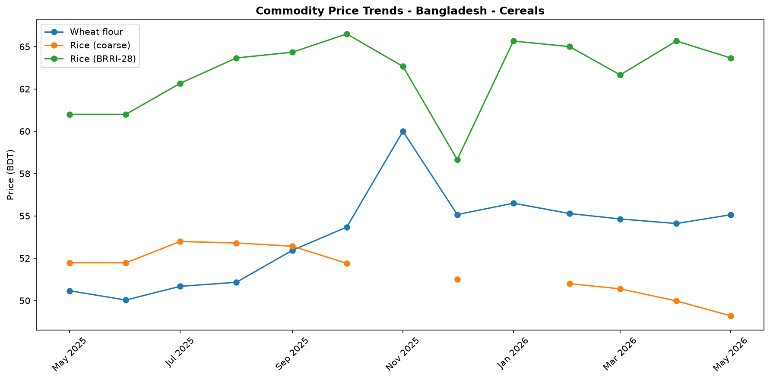
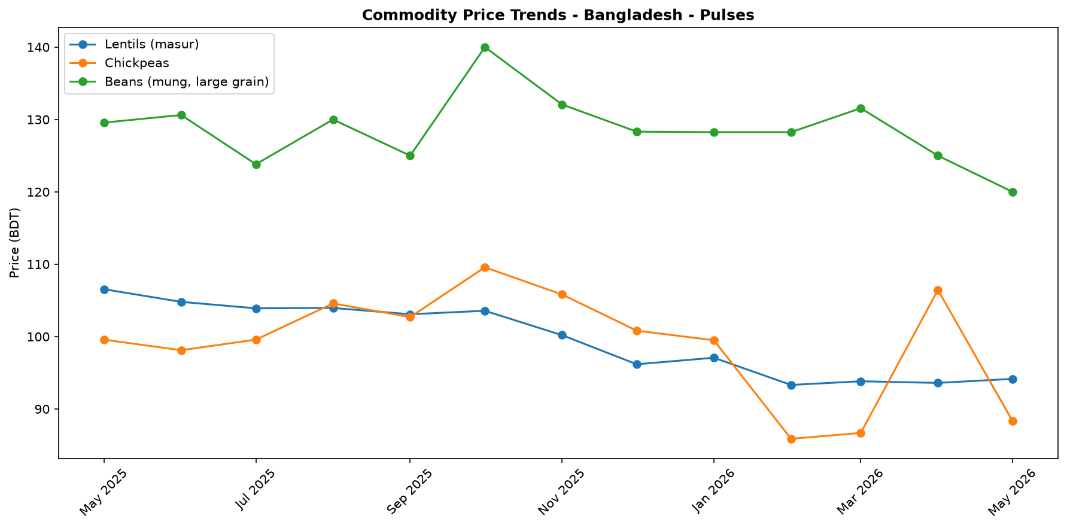
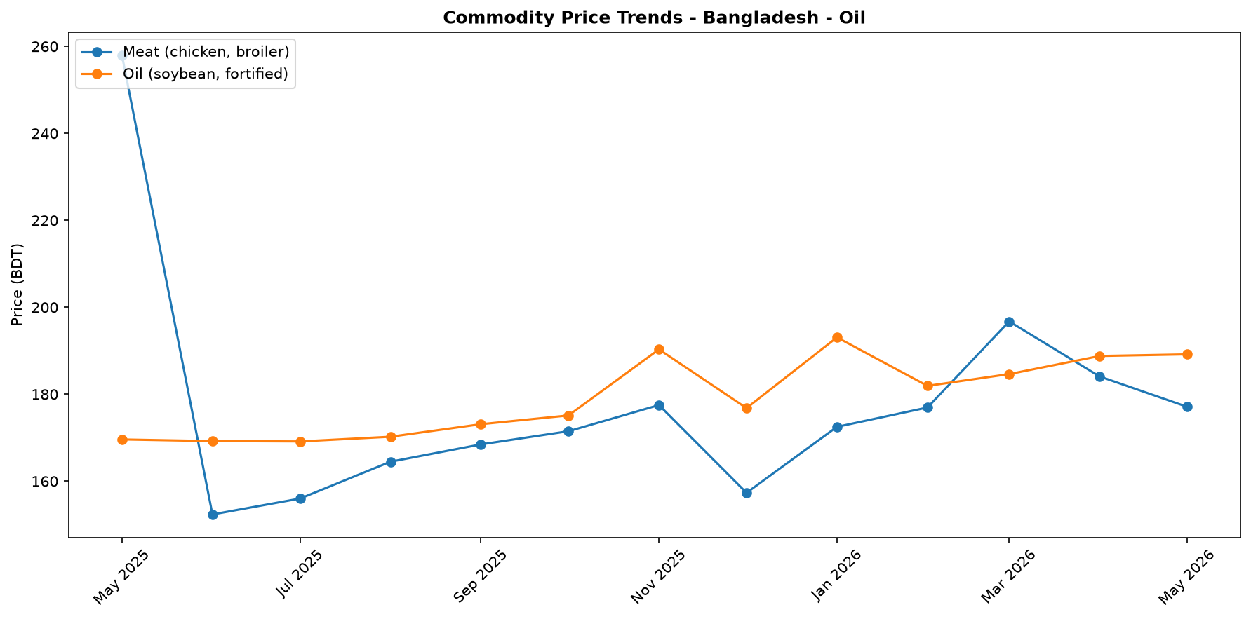
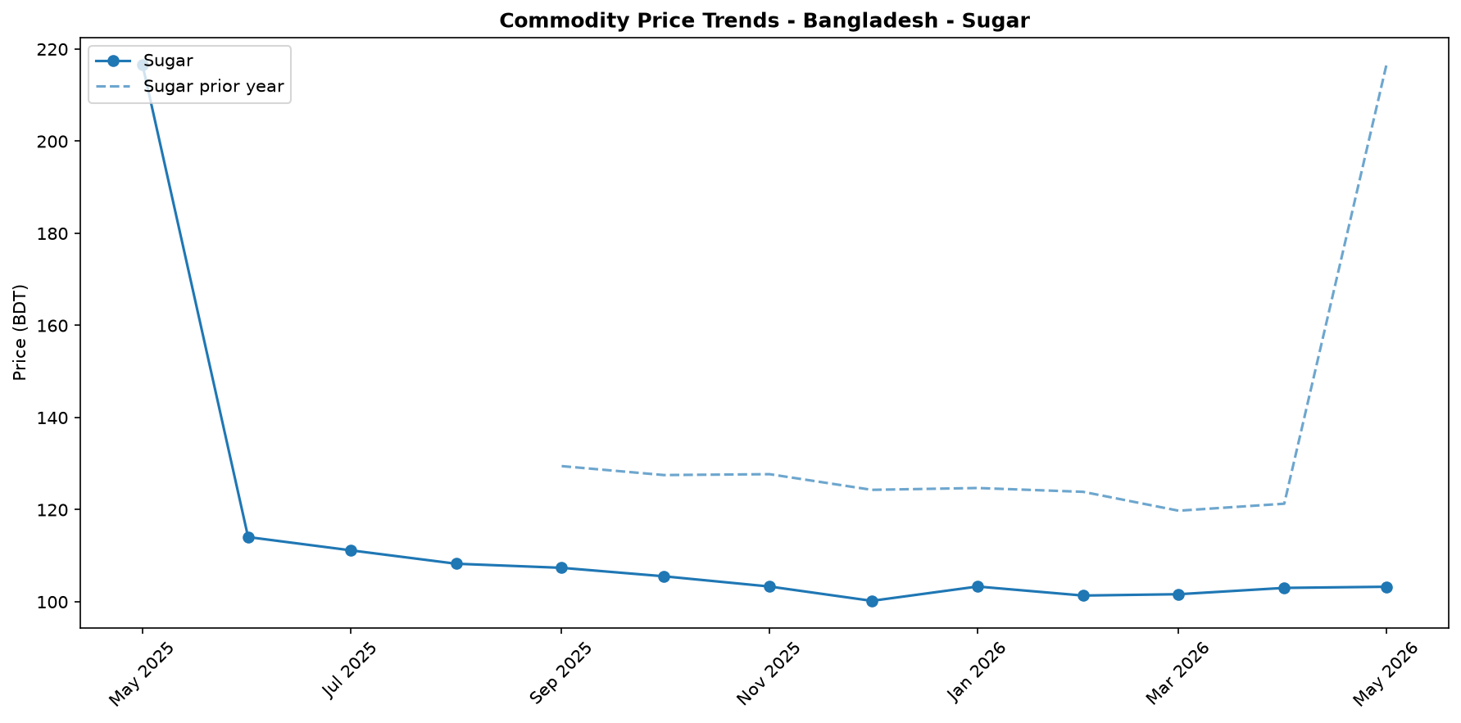
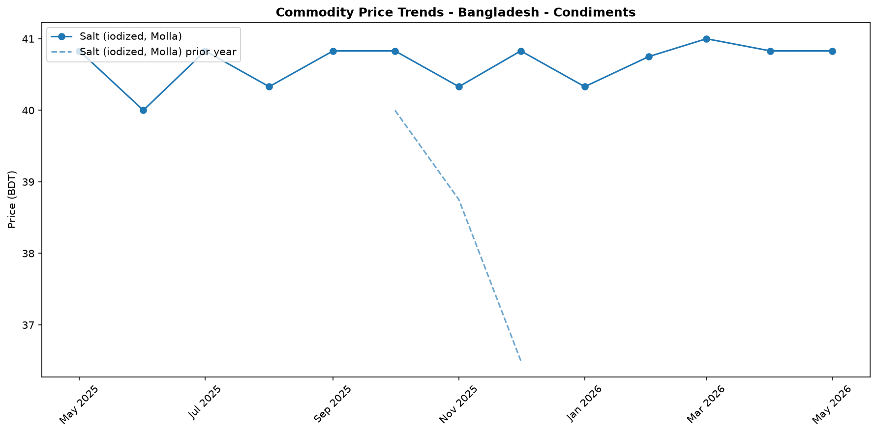
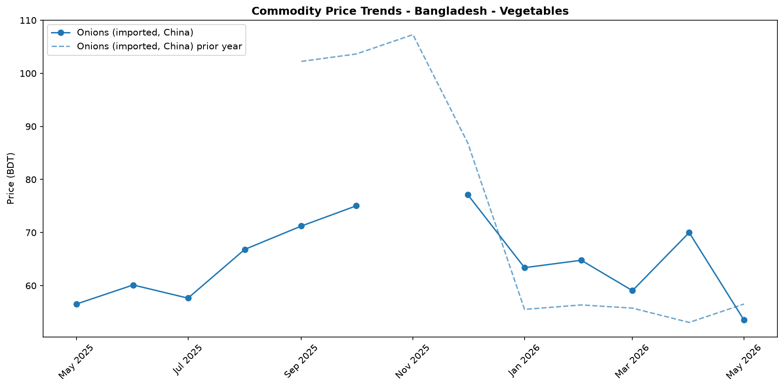
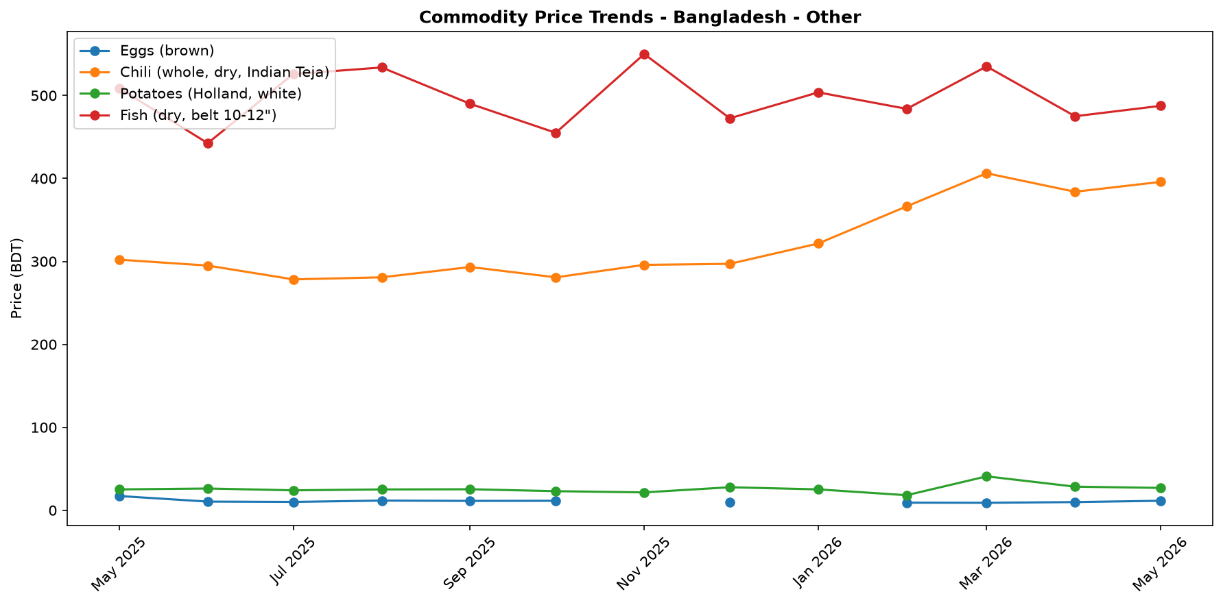

Regional Highlights
At the national level, the cost of the "MEB" food basket increased by 0.6% month-on-month but decreased by 9.2% year-on-year. However, regional analysis is constrained by significant data gaps. Chittagong was the only region with complete data for all 13 basket components, preventing a comprehensive regional cost comparison. In Chittagong, the basket cost was 1,519.4 BDT, reflecting a 3.6% decrease compared to the same period last year; month-on-month data was not available for this region.
For all other monitored regions—Barisal, Dhaka, Khulna, Mymensingh, Rajshahi, Rangpur, and Sylhet—a total basket cost could not be calculated due to missing price data for several commodities. Items frequently missing from regional datasets included 'Chickpeas', 'Chili (whole, dry, Indian Teja)', 'Fish (dry, belt 10-12")', and 'Salt (iodized, Molla)'. These persistent data gaps suggest potential challenges in data collection or localized availability issues for these specific goods, limiting the ability to assess market conditions and household purchasing power at a sub-national level.
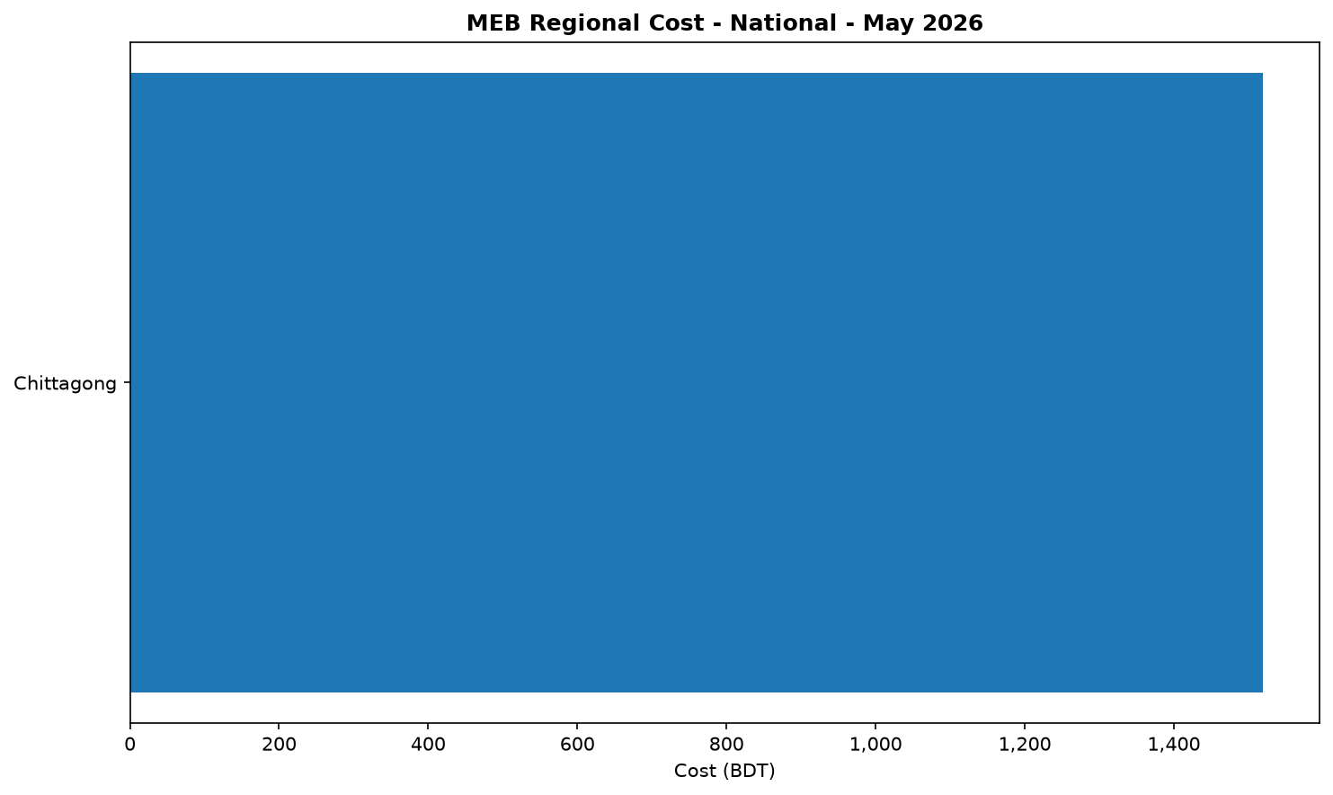

Exchange Rate Analysis
The official exchange rate remained stable, trading at 122.8 BDT per USD. Month-on-month, the BDT held steady against the USD with a negligible change of 0.0%, a positive development for containing the cost of imported goods. However, on a year-on-year basis, the currency experienced a slight depreciation of 0.4%, reflecting a gradual weakening over the past 12 months. While recent stability is welcome, the depreciated annual rate continues to exert upward pressure on the domestic prices of imported staple foods, such as wheat and cooking oil, as well as on fuel prices. The sustained high cost of imports can translate into higher market prices for essential goods, potentially eroding the purchasing power of vulnerable households across the country, particularly those reliant on market purchases for their food needs.

References
- [rw_4214182] ReliefWeb (2026-05-31) Finland boosts support for Rohingya refugees with EUR 2 million contribution [EN/BN]
https://reliefweb.int/node/4214182
- [rw_4214118] ReliefWeb (2026-05-29) Period poverty: A global menstrual health crisis
https://reliefweb.int/node/4214118
- [rw_4213869] ReliefWeb (2026-05-28) Asia and the Pacific: Weekly Regional Humanitarian Snapshot (19 - 25 May 2026)
https://reliefweb.int/node/4213869
- [rw_4213682] ReliefWeb (2026-05-26) Homestead Gardening Guidelines - Vegetable production for household consumption using minimal space in Rohingya camps and host communities
https://reliefweb.int/node/4213682
- [rw_4212820] ReliefWeb (2026-05-20) UN and partners appeal for USD 710.5 million to meet the critical needs of Rohingya refugees and Bangladeshi host communities [EN/BN]
https://reliefweb.int/node/4212820
- [rw_4212682] ReliefWeb (2026-05-19) From coverage to prioritisation: how funding cuts are reshaping operational decisions in Cox’s Bazar
https://reliefweb.int/node/4212682
- [rw_4212292] ReliefWeb (2026-05-15) Impact of gardening and nutrition support provided to women in refugee camps in Cox’s Bazar
https://reliefweb.int/node/4212292
- [rw_4212129] ReliefWeb (2026-05-14) Mr. Tom Fletcher, Under-Secretary-General for Humanitarian Affairs and Emergency Relief Coordinator – Remarks to the press on US humanitarian funding at UN Headquarters, 14 May 2026
https://reliefweb.int/node/4212129
- [rw_4212067] ReliefWeb (2026-05-14) Sweden announces more than SEK 2.7 billion in humanitarian assistance to the world’s most vulnerable
https://reliefweb.int/node/4212067
- [rw_4211766] ReliefWeb (2026-05-13) UNHCR Regional Bureau for Asia and Pacific: Myanmar Situation Update (Bangladesh, India, Indonesia, Malaysia, Myanmar, and Thailand) January - March 2026
https://reliefweb.int/node/4211766
- [seerist_1028666] Seerist (2026-05-22) Tiger kidnaps to remain rare despite incident involving bank manager in Dhaka district
- [seerist_1028464] Seerist (2026-05-08) Big Picture series: Keep calm and kharif on – fertiliser shock and political risk in South Asia
- [seerist_1028203] Seerist (2026-04-17) Operational, integrity risks to persist in renewable energy sector despite government support
- [seerist_1028169] Seerist (2026-04-16) Political interference, integrity risks likely to remain prevalent in banking sector despite reforms
- [seerist_1028140] Seerist (2026-04-14) Uneven enforcement of new labour law will sustain reputational, unrest risks in manufacturing
- [seerist_1028118] Seerist (2026-04-13) Big Picture series: Asian economies face prolonged energy stress as Middle East disruption persists
- [seerist_1028051] Seerist (2026-04-07) Civil unrest risks to increase amid differences over political reforms

